The Horace Mann League of the USA 2015 Winter Newsletter

Greetings from the 2015-2016 officers and directors of the Horace Mann League. Best wishes for the coming holidays.

As we find time in this busy season to sit back and reflect on the news about public education in the United States, there is much about which to be pleased, proud, and, also, concerned. In speaking about Horace Mann’s views on education, historian Ellwood Cubberly observed that Mann believed education should be “universal, non- sectarian, free, and that its aims should be social efficiency, civic virtue, and character, rather than mere learning or the advancement of sectarian ends.” In furthering this view, the League in this past year has pursued an agenda designed to bring attention to the impact on learning of social and economic inequities through its Iceberg Effect project, and to publicly applaud the seminar work of leaders like Pedro Noguera, Gene Carter, Mark Edwards, Gary Marx, Gene Glass and Andy Hargreaves. Our own Executive Director, Jack McKay, was, himself, recently applauded for his “advocacy for education” by Washington State University.

Much challenge still lies ahead of us as we increasingly confront growing political support for notions like private-school vouchers (aka “scholarships”), tax credits, and high-stakes assessments which ignore cultural and language differences. We need to increase the strength of our voices in both highlighting the accomplishments of those we publicly applaud at our meetings, and in bringing public attention to the policies which imperil Horace Mann’s vision of our nation’s system of public schools. We encourage each member to enlist at least one other person in our effort by joining the ranks of the Horace Mann League. This can be easily accomplished by going to the HML website (www.hmleague.org) By strengthening our numbers and our resolve, we can keep the Horace Mann vision alive.

Chuck Fowler, President of the Horace Mann League

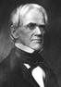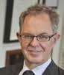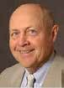HML Outstanding Friend of Public Education— Andy Hargreaves
Andy Hargreaves is the Chair in the Lynch School of Education at Boston College. Andy has authored or edited over 30 books, several of which have achieved outstanding writing awards for the AERA, the ALA, and the AACTE. One of these, Professional Capital: Transforming Teaching in Every School (with Micheal Fullan, 2012), has received three awards.
His most recent book is Uplifting Leadership (with Alan Boyle and Alma Harris) published by Jossey Bass Business, 2014.

The League’s Outstanding Public Educator – Gene Glass
Gene Glass is a researcher working in educational psychology and the social sciences. He coined the term "meta-analysis" and illustrated its first use in 1976. Gene Glass is a Regents' Professor Emeritus at Arizona State University in both the educational leadership and psychology in education divisions, having retired in 2010.
Currently, Glass is a senior researcher at
the National Education Policy Center and a research professor in the School of Education at the University of Colorado Boulder.

The Horace Mann League of the USA 2015 Winter Newsletter 2
Officers and Directors of the Horace Mann League 2015 -2016

President-elect: Charles Fowler, Exec. Secretary Suburban Sch. Supts., Exeter, NH

Laurie Barron, Supt. of Schools, Evergreen Schools District, Kalispell, MT

President-elect: Chris Johns- Haines, Supt., Utica Comm.
Schools, Sterling
Heights, MI.

Jeff Charbonneau, Science Director Zillah Sch. Dist., Zillah, WA

Vice President: Martha Bruckner, Supt. of Schs., Council Bluffs Comm. Schools, IA

Carol Choye, Instructor, Bank Street College, NY

President: Gary Marx, Pres. Center for Public Outreach, Vienna, VA

Brent Clark, Exec Director Illinois Assoc. Sch. Admin. Springfield, IL

1st Past President: Joe Hairston, Assoc. Professor, Howard Univ., Washington. DC

Linda Darling- Hammond, Professor, Stanford University, Palo Alto, CA.

Evelyn Holman, Supt. (former) Bay Shore USD, Bay Shore, NY
James Harvey, Exec. Dir., National Supts. Roundtable Seattle, WA
Eric King, Supt. (retired) Muncie Public Schools, Muncie, IN

Steven Ladd, Supt., (Retired) Elk Grove USD, Elk Grove, CA
Barry Lynn, Exec. Director Americans United.
Washington DC

Kevin Maxwell, CEO, Prince George’s County Schools, Upper Marlboro, MD
Stan Olson, Director, Silverback Learning, Boise, ID
Steven Webb, Supt. of Schools, Vancouver, School District, Vancouver, WA

Jack McKay, Exec. Dir.
Horace Mann League, WA

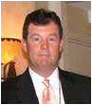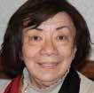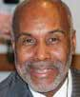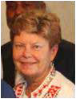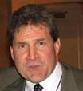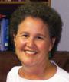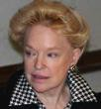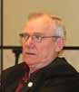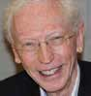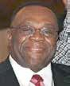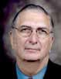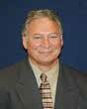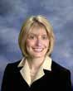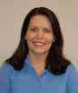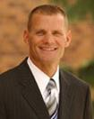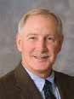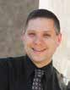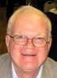

2

The Horace Mann League of the USA 2015 Winter Newsletter 3
The Horace Mann League Outstanding Public Educator Award Recipients

2016
Andy Hargreaves, Professor, Boston College
2015,
Gene Carter, Emeritus Exec. Dir, ASCD
2014,
Larry Cuban, Professor, Stanford University
2006,
Gerald Tirozzi, Executive Director, NASSP
2013, | 2011, | 2010, | 2009, | 2008, | 2007,
Tom | Ken Bird, | Paul | Harry | Carroll | Linton
Payzant | CEO, | Schlechty, | Wong, | Johnson, | Deck,
Professor | Avenue | Author | Author | Prof. | Professor
Harvard | Scholars, | Speaker | Effective | Columbia | Peabody
University | Omaha,  NE |  | Teaching | University | College

2005 Linda Darling- Hammond, Prof., Author, Stanford U.

2004 Julie Underwood, Chief Counsel, NSBA / Dean
- of Wisconsin

2003 Ted
Sanders, President, Education Comm. of the States

‘02 Gerald Bracey, Author War Against Public School

‘01 Paul Houston, Executive Director, AASA

2000 Jane Hammond, Supt, Jeff. Co. Public Schools
1999 Bob
Slavin, Research, John Hopkins University
1998 Don
Thomas, Supt. Salt Lake City, UT
1997 David Berliner, Co- author The Manufactured Crisis
1996 Gordon Cawelti, Exec. Dir., Alliance for Curriculum Reform

The Horace Mann League Outstanding Friend of Public Education Recipients

’16 Gene Glass, Professor, Author, National Ed. Policy Center

‘15 Pedro Noguera, Professor, author, New York University
‘14 Marian Wright Edelman, Pres.
Children’s Defense Fund
‘12 Mark Warner, U.S.
Senator, Virginia
’11 Jack Jennings. CEO. Center for Public Policy, Wash, DC
‘10 Diane Ravitch, Author, Researcher, Speaker, New York
‘09
Michael Kirst, Prof., Pol. Sci.
Stanford University
‘08 John Goodlad, Author, The Place Called School

‘07 Wendy Puriefoy, Pres., Public Education Network
’06 Tom Sobol, State Comm., New York State Dept. of Educ.

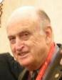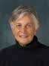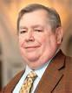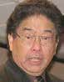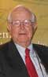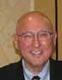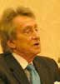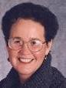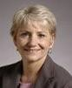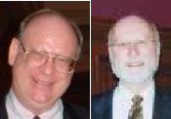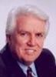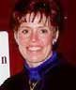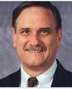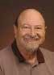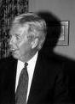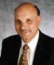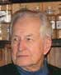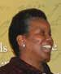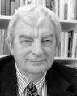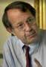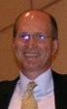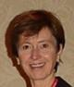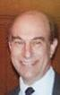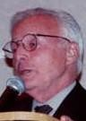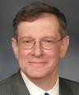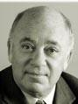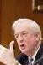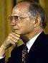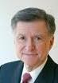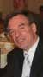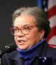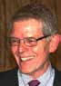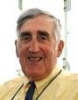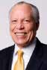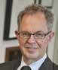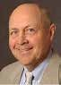
5

‘05 | ‘04 Larry | ‘03 Mary | ‘02 Richard | ‘01 Al | ’00 Barry | ‘98 Lew | ‘97 James | ‘96 | ‘95 Larry
Jonathan | Stupski, | Fitsgerald, | Rothstein, | Dietzel, | Lynn, Exec. | Salmon | Hunt, | Richard | Lezotte,
Kozol, The | The Stupski | Readers' | The New | V.P. The | Director, | The Milken | Gov. of | Riley, U.S. | Effective
Shame of | Foundation | Digest | York Times | Limited | Americans | Foundation | North | Secretary | Schools
Our |  | Fund |  | Co. | United |  | Carolina | Education | Research
Nation
3
5

The Horace Mann League of the USA 2015 Winter Newsletter
6
4

Past Presidents of the Horace Mann League
Past Presidents of the Horace Mann League
Year President State Year President State 1922 Carroll C. Pearse WI 1986 M. Donald Thomas UT 1926 Payson Smith ME 1987 Patrick T. Hoban WA 1930 George M. Child UT 1988 Linton Deck NC 1931 George M Strayer NY 1989 Jack K. Mawdsley MI 1932 Fred M. Hunter OR 1990 John Prasch NE 1933 E.E. Oberholtzer TX 1991 Ron E. Etheridge OH 1934 H. Lester Smith IN 1992 Robert Fortenberry MS 1935 John K. Norton NY 1993 Malcolm Katz GA 1936 Ben G. Graham PA 1994 Edna Manning OK 1937 Millard C. Leffler NE 1995 Paul Houston VA 1938 John A. Sexton CA 1996 Terry Grier CA 1939 Willard E. Given DC 1997 Cleve. Hammonds MO 1940 Alexander Stoddard RI 1998 Jane Hammond CO 1941 L. J. Nuttall UT 1999 Beverly Reep OH 1942 Harold J. Benjamin MD 2000 Kenneth Bird NE 1944 Homer Anderson MA 2001 Benjamin Canada OR 1946 Howard R. Driggs NY 2002 Arthur Stellar MI 1947 James Edmonson MI 2003 Larry Dlugosh NE 1948 I.E.F. Williams OH 2004 Spike Jorgensen AK 1950 Benjamin L. Smith NC 2005 John Simpson VA 1951 Mark A. Smith GA 2006 Walter Warfield IL 1953 Virgil M. Rogers VA 2007 Colleen Wilcox CA 1955 Selmer H. Berg CA 2008 Fred Hartmeister TX 1957 Henry H. Hill TN 2009 Steven Rasmussen WA 1958 Richard B. Kennan MD 2010 George Garcia AZ 1959 Edgar Fuller DC 2011 Julie Underwood MN 1960 L. Stacy Weaver NC 2012 Mark Edwards NC 1962 Frank W. Cyr NY 2013 Joe Hairston MD 1963 John L. Buford IL 2014 Gary Marx VA 1964 M. Lynn Bennion UT 2015 Charles Fowler NH 1965 Shirley Cooper WV
1966 T. Edward Rutter CT 1967 Phillip J. Weaver NC 1968 J. Chester Swanson CA 1969 Edgar W. Davis CT 1970 Walter L. Hetzel IA
1971 Eugene H. Mellon IL Executive Secretary/Director
1972 Milldred Reid DC 1922 John A. Smith 1973 George B. Brain WA 1923 John R. Kirk 1974 Archibald B. Shaw MI 1924 Robert H. Wright 1975 Frank R. Yulo CT 1925-45 Carroll Pearse
1976 Charles H. Weaver NC 1946-54 Joy Elmer Morgan 1977 Paul W. Rossey NJ 1955-59 E.I. F. Williams 1978 W. J. House NC 1959-62 Benj. L. Smith 1979 Homer O. Elseroad CO 1963-71 William A. Early 1980 Kenneth H. HansenCO 1972-77 Clayton Hutchins 1981 Albert L. Ayars VA 1977-91 Robert D. Fleischer 1982 Orvin L. Plucker KS 1992-93 Paul Rossey
1983 Paul A. Shelly NJ 1993- Jack McKay 1984 Floyd W. Parsons AR
1985 M. Anne Campbell NE
Year President State Year President State 1922 Carroll C. Pearse WI 1986 M. Donald Thomas UT 1926 Payson Smith ME 1987 Patrick T. Hoban WA 1930 George M. Child UT 1988 Linton Deck NC 1931 George M Strayer NY 1989 Jack K. Mawdsley MI 1932 Fred M. Hunter OR 1990 John Prasch NE 1933 E.E. Oberholtzer TX 1991 Ron E. Etheridge OH 1934 H. Lester Smith IN 1992 Robert Fortenberry MS 1935 John K. Norton NY 1993 Malcolm Katz GA

Recent Past Presidents

1936 Ben G. Graham PA 1994 Edna Manning OK 1937 Millard C. Leffler NE 1995 Paul Houston VA 1938 John A. Sexton CA 1996 Terry Grier CA 1939 Willard E. Given DC 1997 Cleve. Hammonds MO 1940 Alexander Stoddard RI 1998 Jane Hammond CO 1941 L. J. Nuttall UT 1999 Beverly Reep OH 1942 Harold J. Benjamin MD 2000 Kenneth Bird NE 1944 Homer Anderson MA 2001 Benjamin Canada OR 1946 Howard R. Driggs NY 2002 Arthur Stellar MI 1947 James Edmonson MI 2003 Larry Dlugosh NE 1948 I.E.F. Williams OH 2004 Spike Jorgensen AK 1950 Benjamin L. Smith NC 2005 John Simpson VA 1951 Mark A. Smith GA 2006 Walter Warfield IL
’15 Charles
Fowler NH

’12 Mark

‘11 Julie
’14 Gary
Marx VA

’10 George
’13 Joe
Hairston MD

‘09 Steve

1953 Virgil M. Rogers VA 2007 Colleen Wilcox CA
1955 Selmer H. Berg CA 2008 Fred Hartmeister TX 1957 Henry H. Hill TN 2009 Steven Rasmussen WA 1958 Richard B. Kennan MD 2010 George Garcia AZ 1959 Edgar Fuller DC 2011 Julie Underwood MN 1960 L. Stacy Weaver NC 2012 Mark Edwards NC 1962 Frank W. Cyr NY 2013 Joe Hairston MD 1963 John L. Buford IL 2014 Gary Marx VA 1964 M. Lynn Bennion UT 2015 Charles Fowler NH 1965 Shirley Cooper WV
Edwards NC
Underwood MN
Garcia CO
Rasmussen WA

1966 T. Edward Rutter CT 1967 Phillip J. Weaver NC 1968 J. Chester Swanson CA 1969 Edgar W. Davis CT 1970 Walter L. Hetzel IA
1971 Eugene H. Mellon IL Executive Secretary/Director
1972 Milldred Reid DC 1922 John A. Smith 1973 George B. Brain WA 1923 John R. Kirk 1974 Archibald B. Shaw MI 1924 Robert H. Wright 1975 Frank R. Yulo CT 1925-45 Carroll Pearse
1976 Charles H. Weaver NC 1946-54 Joy Elmer Morgan 1977 Paul W. Rossey NJ 1955-59 E.I. F. Williams 1978 W. J. House NC 1959-62 Benj. L. Smith 1979 Homer O. Elseroad CO 1963-71 William A. Early 1980 Kenneth H. HansenCO 1972-77 Clayton Hutchins 1981 Albert L. Ayars VA 1977-91 Robert D. Fleischer 1982 Orvin L. Plucker KS 1992-93 Paul Rossey
1983 Paul A. Shelly NJ 1993- Jack McKay 1984 Floyd W. Parsons AR
1985 M. Anne Campbell NE
‘ 08 Fred Hartmeister TX

’03 Larry Dlugosh NE

’98 Jane Hammond CO
’07 Colleen
Wilcox CA

’02 Art Stellar MA

’97 Cleve. Hammonds MO
’06 Walt
Warfield IL

’01 Ben Canada OR

’96 Terry Grier
NC
’05 John
Simpson VA

’00 Ken Bird NE

’95 Paul Houston CA
’04 Spike
Jorgensen AK

’99 Bev.
Reep OH

94 Edna Manning OK

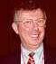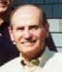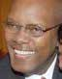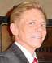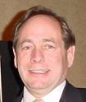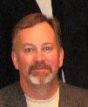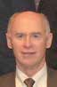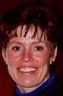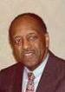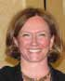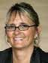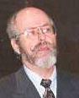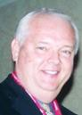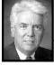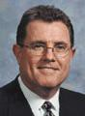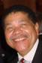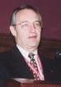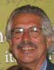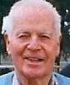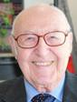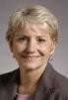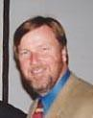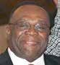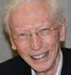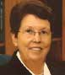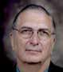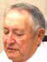’93 Malcom Katz. MI

4
6
’92 Robert Fortenberry MI
’88 Linton Deck TN
’87 Pat Hoban WA
’86 Don Thomas UT
’73 George Brain WA

The Horace Mann League of the USA 2015 Winter Newsletter
3
5
Nominations for Officers and Director 2016-2017

President

Chris Johns- Haines, Supt., Utica Community Schools, Sterling Heights, MI.
President
- Elect

Martha Bruckner, Supt. of Schools, Council Bluffs Comm. Schools, IA
Vice President

Eric King, Supt. (retired) Muncie Public Schools, Muncie, IN
Director

Ember Conley, Supt. Park City Schools, Park City, UT
Director

Ruben Alejandro, Supt.
Weslaco ISD, Weslaco, TX
1st Past President

Charles Fowler, Exec. Secretary Suburban Sch. Supts., Exeter, NH
2nd Past President

Gary Marx, Pres. Center for Public Outreach, Vienna, VA

Activities and Accomplishments of the Horace Mann League in 2015
  - The “Iceberg Effect” presented at the National Press Club in Washington, DC
  - “Iceberg Effect” referenced in over 700 other newspapers, blogs, and other media outlets.
  - Drs. Pedro Noguera, Gene Carter and Mark Edwards recognized at 2015 HML Annual Meeting.
  - HML Board confronts issues of student inequity and opportunity at summer board meeting.
  - New member recruitment campaign to nominate or sponsor a new member.
  - HML Facebook created to increase methods of communication to members.
  - Drs. Gene Glass and Andy Hargreaves selected as “Outstanding” recipients at the 2016 meeting.
  - Mr. Gary Marx, Past President of the HML, selected to receive the “Friend of the League” award. Ongoing Activities:
- Weekly publication of the HML Post.
- Update membership data-base, dues, renewals and recruitment.

94th Annual Meeting of the Horace Mann League - Registration Form
Friday, February 12, 2016, Phoenix Downtown Sheraton Hotel, 11:45 am to 1:30 pm.

Name: Guest(s)
Address:
City, State, ZIP:

Number Attending _ at $65.00 = Make check to:
The HML 560 Rainier Lane, Port Ludlow, WA 98365 (FAX: 866 389 0740) Email: jmckay@hmleague.org Credit Card Information – email to jmckay@hmleague.org

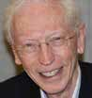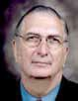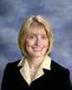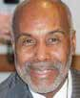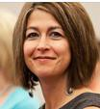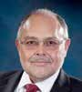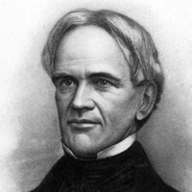CC# – – – Phone: ( ) –
Exp. Date /

5
3

HML, 560 Rainier Lane Port Ludlow, WA 98365

PRSRT STD
U.S. POSTAGE
PAID
PERMIT 14 SOS PRINTING

